Pokhara University

Level: Bachelor | Semester – Spring | Year : 2007
Programme: BE |  | Full Marks: 100
Course: Engineering Mathematics I |  | Time : 3hrs.

Candidates are required to give their answers in their own words as far as practicable.
The figures in the margin indicate full marks.

Attempt all the questions.

 | - A function is defined as follows  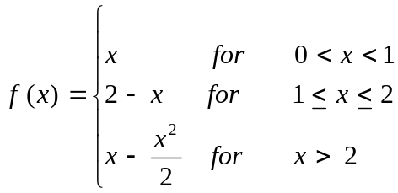  Is 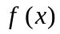 continuous at x = 1 and x = 2? Does 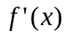 exist for these values?  OR  If y = (sin⁻¹ x)², prove that (1 – x²) y₂ – xy₁ – 2 = 0 and hence show that (1 – x²) y_{n+2} – (2n +1) xy_{n+1} – n² y_{n} = 0 .  - State and prove Lagrange’s mean value theorem. Use it to show that if f (x) > 0 in [a, b] function f(x) is increasing in [a, b]. | 8  7
 | - Evaluate 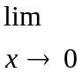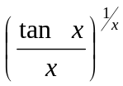  - Find the altitude of the right circular cylinder of maximum volume that can be inscribed in a given right circular cone of height h.  OR  Find the radius of curvature of  + 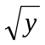 = 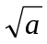 at the point where y = x cuts it. | 7  8
 | Integrate any three of the following:  - 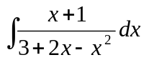  - 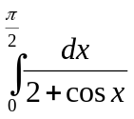  - 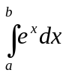  - 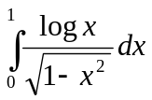 | 3×5
 | - Find the area enclosed by y² – 4x = 4 and 4x – y = 16.  OR  Find the volume of the solid formed by revolving the area bounded by x² = y and y = 2x about y – axis.  - Use Simpson’s rule with n = 4 to approximate the area between y = (2x + 1)², ordinates at x = 1, x = 3 and x – axis. Also evaluate the same by using trapezoidal rule. | 7  8
 | - Define hyperbola and derive its standard equation in the form of 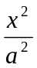 - 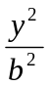 = 1.  - Find the center, vertices, eccentricity and foci of the ellipse.  9x² + 16y² + 18x – 96y + 9 = 0  OR  Find the condition that the line lx + my = p may be a tangent to the parabola y² = 4ax. | 8  7
 | - Using vector method obtain the equation of the plane through (2, 1, - 1) which is perpendicular to the line of the intersection of the planes 2x + y – z = 3, x + 2y + z = 2.  - Show that (a × b) × c = a × (b × c) if and only if a and c are collinear vectors.  OR  Show that the points A, B, C and D having position vectors – 6i + 3j + 2k, 3i – 2j + 4k, 5i + 7j + 3k and -13i + 17j - k are coplanar. | 7  8
 | Solve the following:  - Find domain and range of the function y = 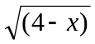.  - Evaluate 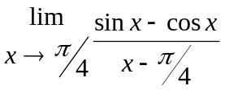.  - Find the vertex, focus, and directrix of the parabola 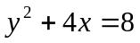.  - Find the arc length of the curve, 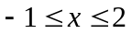.  - Evaluate 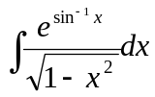 | 5×2

